Bohol FiveHearts Travel & Tours - Complete Website Package

---

1. Project Folder Structure

bohol-fivehearts-website/
├── index.html # Main homepage
├── css/
│ └── style.css # Custom styles
├── js/
│ └── script.js # Custom JS (menu, scroll, AOS)
└── images/ # All destination and package images
├── chocolate-hills.jpg
├── tarsier.jpg
├── loboc-river.jpg
├── alona-beach.jpg
├── balicasag-island.jpg
├── man-made-forest.jpg
├── hinagdanan-cave.jpg
├── punta-cruz.jpg
├── ingkumhan-falls.jpg
├── blood-compact-shrine.jpg
├── bohol-adventure.jpg
├── island-hopping.jpg
└── nature-escape.jpg

Index.html

<!DOCTYPE html>
<html lang=”en”>
<head>
<meta charset=”UTF-8”>
<meta name=”viewport” content=”width=device-width, initial-scale=1.0”>
<title>Bohol FiveHearts Travel & Tours</title>

<!—Tailwind CSS
<link href=https://cdn.jsdelivr.net/npm/tailwindcss@3.3.2/dist/tailwind.min.css rel=”stylesheet”>

<!—AOS Animations
<link href=https://cdnjs.cloudflare.com/ajax/libs/aos/2.3.4/aos.css rel=”stylesheet”>

<!—Google Fonts
<link href=https://fonts.googleapis.com/css2?family=Playfair+Display:wght@700&family=Open+Sans:wght@400;600&display=swap rel=”stylesheet”>

<!—Custom CSS
<link rel=”stylesheet” href=”css/style.css”>
</head>
<body class=”bg-gray-50”>

<!—NAVBAR
<header class=”fixed w-full z-50 navbar shadow-md”>
<div class=”max-w-7xl mx-auto px-4 flex justify-between items-center h-16”>
<a href=”#home” class=”text-teal-800 font-bold text-xl sm:text-2xl”>Bohol FiveHearts</a>
<nav class=”hidden md:flex gap-6 text-gray-700 font-semibold”>
<a href=”#home” class=”nav-link”>Home</a>
<a href=”#destinations” class=”nav-link”>Destinations</a>
<a href=”#packages” class=”nav-link”>Packages</a>
<a href=”#contact” class=”nav-link”>Booking</a>
</nav>
<div class=”md:hidden”>
<button id=”mobile-menu-btn” class=”text-gray-700”>☰</button>
</div>
</div>
<div id=”mobile-menu” class=”hidden flex-col items-center md:hidden bg-white shadow-md”>
<a href=”#home” class=”py-2 px-4 w-full text-center hover:bg-gray-100”>Home</a>
<a href=”#destinations” class=”py-2 px-4 w-full text-center hover:bg-gray-100”>Destinations</a>
<a href=”#packages” class=”py-2 px-4 w-full text-center hover:bg-gray-100”>Packages</a>
<a href=”#contact” class=”py-2 px-4 w-full text-center hover:bg-gray-100”>Booking</a>
</div>
</header>

<!—HERO
<section id=”home” class=”relative h-screen bg-cover bg-center” style=”background-image: url(‘images/chocolate-hills.jpg’);” data-aos=”fade-in”>
<div class=”absolute inset-0 bg-black opacity-50”></div>
<div class=”relative z-10 flex flex-col justify-center items-center h-full text-center px-4”>
<h1 class=”text-5xl sm:text-7xl font-bold text-white mb-4 drop-shadow-lg”>Bohol FiveHearts Travel & Tours</h1>
<p class=”text-lg sm:text-2xl text-gray-200 mb-6 drop-shadow-md”>Explore Bohol’s iconic destinations with the best travel experience</p>
<a href=”#destinations” class=”btn-gradient text-white px-6 py-3 rounded-full transition”>See Destinations</a>
</div>
</section>

<!—DESTINATIONS
<section id=”destinations” class=”py-20 max-w-7xl mx-auto px-4”>
<h2 class=”text-4xl font-bold text-center mb-12 text-teal-800” data-aos=”fade-up”>Iconic Destinations sa Bohol</h2>
<div class=”grid grid-cols-1 sm:grid-cols-2 lg:grid-cols-3 gap-10”>
<!—Repeat for each destination using respective image from images/ folder
</div>
</section>

<!—TOUR PACKAGES
<section id=”packages” class=”py-20 bg-gray-50 max-w-7xl mx-auto px-4”>
<h2 class=”text-4xl font-bold text-center mb-12 text-teal-800” data-aos=”fade-up”>Our Tour Packages</h2>
<div class=”grid grid-cols-1 sm:grid-cols-2 lg:grid-cols-3 gap-10”>
<!—Repeat for each package with images from images/ folder
</div>
</section>

<!—CONTACT
<section id=”contact” class=”py-20 max-w-7xl mx-auto px-4” data-aos=”fade-up”>
<h2 class=”text-4xl font-bold text-center mb-10 text-teal-800”>Book Your Tour</h2>
<form class=”max-w-xl mx-auto bg-white p-10 rounded-2xl shadow-xl flex flex-col gap-5”>
<input type=”text” placeholder=”Full Name” class=”border p-4 rounded-md w-full”>
<input type=”email” placeholder=”Email Address” class=”border p-4 rounded-md w-full”>
<input type=”tel” placeholder=”Phone Number” class=”border p-4 rounded-md w-full”>
<textarea placeholder=”Message / Tour Details” class=”border p-4 rounded-md w-full”></textarea>
<button type=”submit” class=”btn-gradient text-white px-6 py-3 rounded-full text-lg w-max self-center transition”>Send Booking</button>
</form>
</section>

<!—BACK TO TOP
<div id=”back-to-top” title=”Back to top”>↑</div>

<!—FOOTER
<footer class=”bg-teal-800 text-white py-6 text-center”>
<p>&copy; 2025 Bohol FiveHearts Travel & Tours. Owner: Daina Mañing. All rights reserved.</p>
</footer>

<!—Scripts
<script src=https://cdnjs.cloudflare.com/ajax/libs/aos/2.3.4/aos.js></script>
<script src=”js/script.js”></script>
</body>
</html>

Css/style.css

Html { scroll-behavior: smooth; }
Body { font-family: ‘Open Sans’, sans-serif; }
H1,h2,h3 { font-family: ‘Playfair Display’, serif; }

.card:hover .bg-cover { transform: scale(1.05); transition: transform 0.5s ease; }
.card:hover { box-shadow: 0 15px 30px rgba(0,0,0,0.35); transition: box-shadow 0.5s ease; }

.btn-gradient { background: linear-gradient(90deg, #0d9488, #facc15); }
.btn-gradient:hover { background: linear-gradient(90deg, #facc15, #0d9488); }

.navbar { backdrop-filter: blur(10px); background-color: rgba(255,255,255,0.85); transition: box-shadow 0.3s ease; }
.navbar.scrolled { box-shadow: 0 4px 15px rgba(0,0,0,0.2); }

.nav-link { position: relative; transition: color 0.3s ease; }
.nav-link::after { content: ‘’; position: absolute; width: 0; height: 2px; left: 0; bottom: -2px; background-color: #0d9488; transition: width 0.3s ease; }
.nav-link:hover::after { width: 100%; }

#back-to-top { position: fixed; bottom: 30px; right: 30px; background-color: #0d9488; color: white; padding: 10px 15px; border-radius: 50%; cursor: pointer; display: none; z-index: 100; transition: background 0.3s ease, transform 0.3s ease; }
#back-to-top:hover { background-color: #facc15; transform: scale(1.1); }

Js/script.js

AOS.init({ duration: 1000, once: true });

Const menuBtn = document.getElementById(‘mobile-menu-btn’);
Const mobileMenu = document.getElementById(‘mobile-menu’);
menuBtn.addEventListener(‘click’, () => { mobileMenu.classList.toggle(‘hidden’); });

const navbar = document.querySelector(‘.navbar’);
const backToTop = document.getElementById(‘back-to-top’);

window.addEventListener(‘scroll’, () => {
if(window.scrollY > 50){ navbar.classList.add(‘scrolled’); backToTop.style.display = ‘block’; }
else{ navbar.classList.remove(‘scrolled’); backToTop.style.display = ‘none’; }
});

backToTop.addEventListener(‘click’, () => {
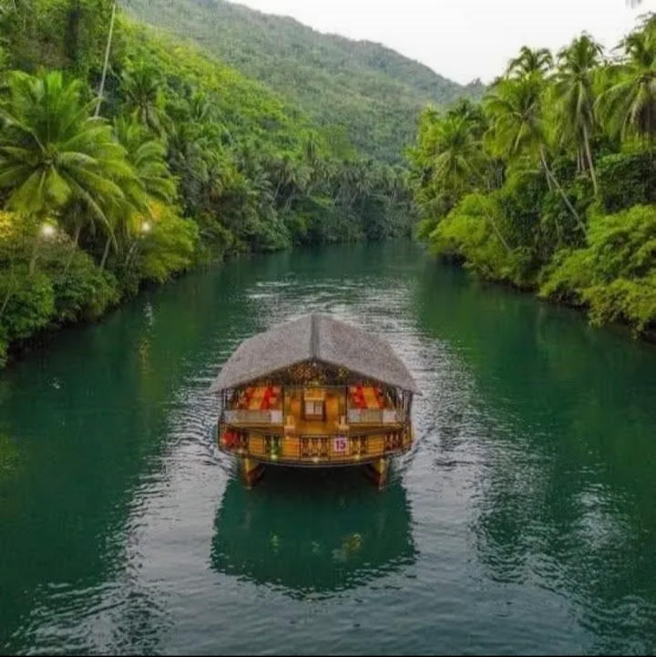
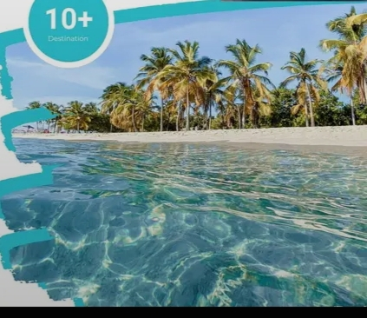
window.scrollTo({ top: 0, behavior: ‘smooth’ });

